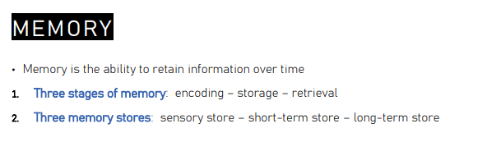

Two distinction of memory:
- Encoding: place information in memory
- Storage: store information
- Retrieval: recall information from the memory storage when we need it

Three memory stores
- Sensory store
- Short-term store
- Long-term store

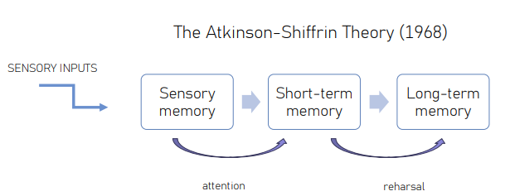

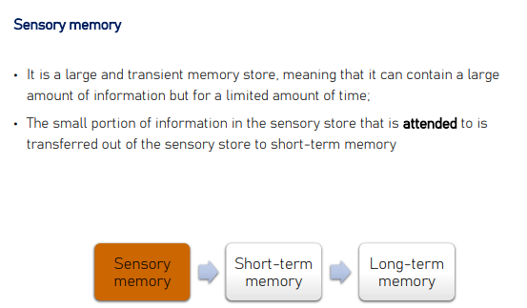

First memory store that we have. It is very large (contain very large information from the environment but for a limited amount of time).

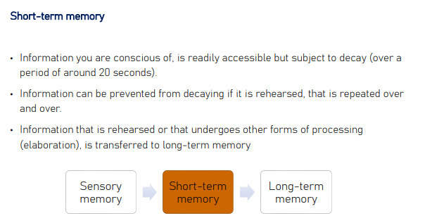
Short time memory contains information you are conscious of. Information available for us only for 20 seconds. It is subject to decay, if we are able to maintain the information active the information can be transferred to the long-term memory.

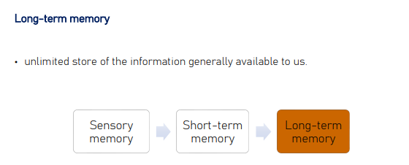
Is the unlimited storage of information.

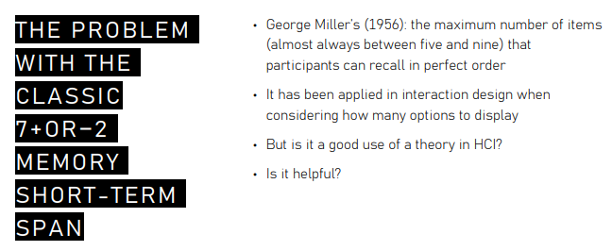

Ask individuals to remember a number of items (in order). The maximum number of items people can recall in the correct order is around 7±2

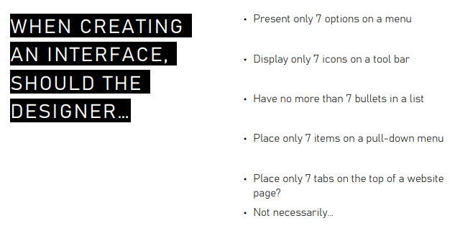
Could use this number to design simple or complex interfaces.

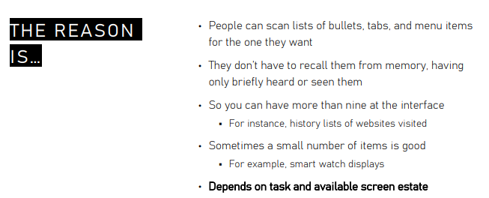

When users are presented with an interface or interact with technology they do not have to recall something from memory.

If our user interact with a technology and does not have to recall an information +compl

If information is on the screen, the user can navigate easily.

+registrazione
Traction the Type of Interface that we are thinking about this so this is a very good point in General.A what's important to a?Your colleagues i lighting is that it's not ok tu.Take principle and apply without thinking about the Type of Technology and the Type of interaction that we are thinking of because we need to consider the Type of system that we are developing

---
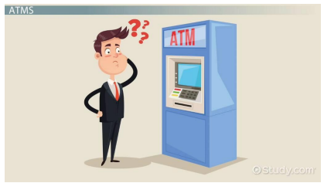
It is common to make mistakes, even with simple technology. Sometimes we make some mistakes (forget something)

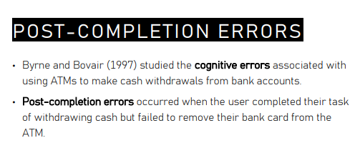
Post-completion errors, users do a task but fail to remove the credit card from the machine. Completion error is when people forget to do something in an action.

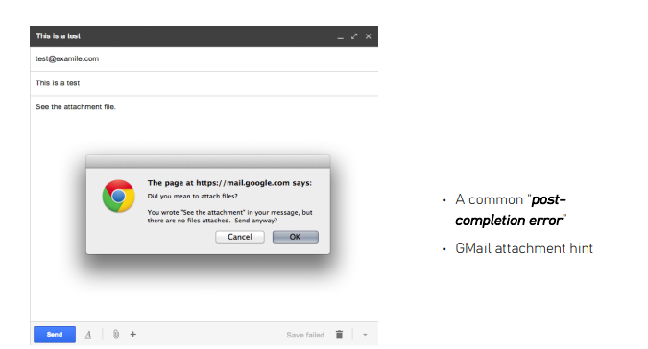
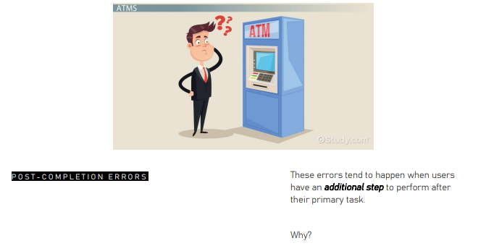

This kind of error occurs when we have to do something more than our primary task.

WORKING MEMORY

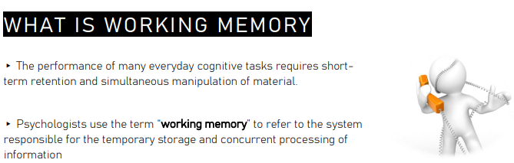

Working memory: system in charge of the storage of information. Maintain the information active to complete the task

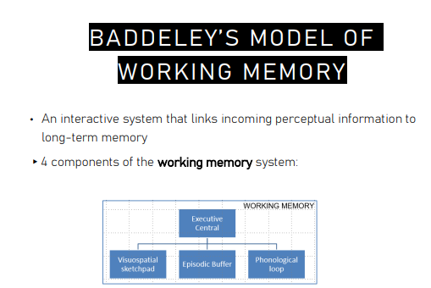
- Executive central
- Visuospatial sketchpad
- Episodic buffer
- Phonological loop

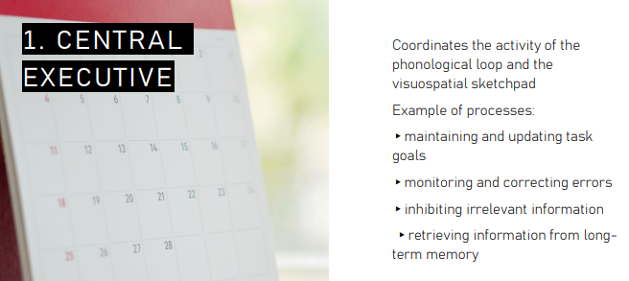
Central executive: is the system in charge of coordinating all the activities of the system.

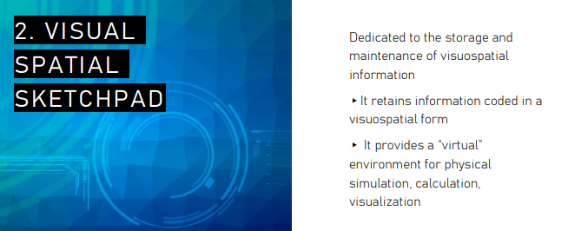

Information is different (can be in different forms). According to the type of information we put the information in different formation

visual-spatial sketchpad is a mental environment that maintains active visual and spatial information.

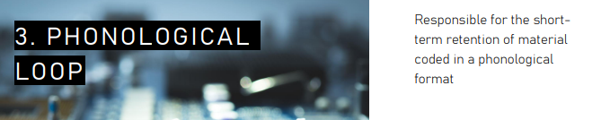
Use to use and maintain material coded in a phonological form.

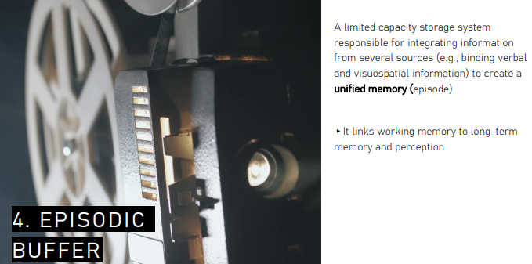
Storage with limited capacity is in charge to integrate information from several sources to create a unified memory (like an episode) it binds together information to create a unified one. Can link working memory to long term memory.

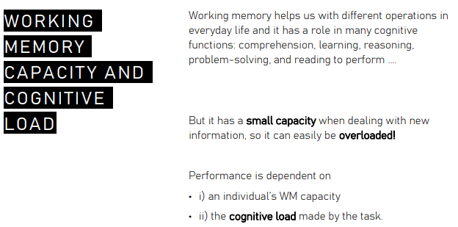

Limit the amount of information that we can maintain.

